Introduction to Section 2:

Symbiosis

In nature, we often witness two or more organisms coexisting harmoniously, engaging in mutually beneficial physiological interactions. Classic examples include clownfish seeking refuge from predators within sea anemones in exchange for providing protection and nutrient-rich excrement, or monarch butterflies pollinating flowers. Yet, we need not look beyond ourselves to recognize symbiotic relationships. In fact, there are more non-human cells residing on and within the human body than actual human cells, thanks to the diverse bacteria, archaea, fungi, and viruses that form our microbiome. This microbiome is now recognized for performing a variety of essential functions, from aiding digestion and nutrient production to protecting against pathogens, and even influencing our mental well-being.
Symbiosis refers to the physiological interaction between two or more unlike organisms. While some microbiologists may not consider the relationship between clownfish and anemones a true symbiosis—since it doesn’t involve direct physiological interaction—most contemporary definitions of symbiosis, especially in animal biology, include persistent biological interactions between different species, such as those between clownfish and sea anemones. There are three primary types of symbiotic relationships: mutualism, commensalism, and parasitism. A common misconception is that symbiosis only refers to beneficial interactions (mutualisms), where both organisms benefit from the relationship. In reality, symbiosis encompasses a broader spectrum, including parasitic and commensal interactions, where the benefits and costs to each organism can vary depending on environmental circumstances and the life stages of the symbionts.
Symbiotic relationships typically evolve over generations, with each organism influencing the other through selective pressures. These relationships have been developing for billions of years and continue to evolve. In this section, we will focus on mutualisms between the Cannabis plant and members of the Kingdom Fungi.
Microbes are ubiquitous across all ecosystems and interact with every organism, sometimes causing disease while at other times promoting health. These microbes are found in remarkable numbers in the air and soil around us. For instance, soil scientists have found that a single gram of soil contains more organisms than the entire human population on Earth—about 10 billion bacterial cells per gram, compared to a global population of 8.2 billion people in 2024 (Raynaud & Nunan, 2014). Microbes play diverse roles in ecosystems, and the microbiomes of complex organisms are essential for maintaining homeostasis. As such, soil organisms interact both directly and indirectly with Cannabis plants.
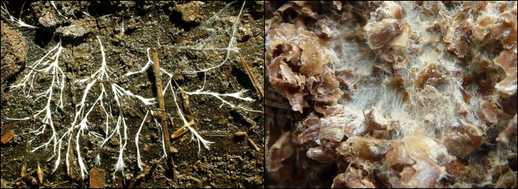
Figure 1. Fungal mycelium growing in soil, digesting organic matter and releasing bioavailable nutrients.

Fungi that directly interact with Cannabis in the soil include mycorrhizal fungi such as Funneliformis and Rhizophagusspecies. Soil saprophytic fungi, ranging from decomposing mushrooms to less-visible molds, play crucial roles in nutrient cycling, water retention, and maintaining the ecological health of the soil microbiome (see Figure 7.2). On the other hand, fungal pathogens can be harmful, often preying on weak plants or certain individuals within a population. In some cases, fungal pathogens can devastate entire crop fields or cause significant economic losses.
Entomopathogenic fungi, which metabolize insects and arthropods as food, provide another example of symbiotic interactions. These fungi consume their hosts and then produce spores to infect new insect or arthropod hosts. Some species may serve as biological control agents, naturally combating pests like aphids, thrips, and whiteflies in agricultural settings, including Cannabis crops. While some entomopathogenic fungi may also act as plant endophytes, promoting plant growth, they can also cause damage, such as the production of fungal sclerotia replacing grain, as seen in Ergot (Claviceps sp.) and Corn Smut (Ustilago maydis).
All of these examples represent symbiotic relationships where organisms of different species interact physiologically, impacting each other's growth and fitness. The primary goal of The Mycology of Cannabis is to explore the various ways Cannabis interacts with fungi—from mutualistic to commensal and parasitic relationships. This understanding offers valuable insights for farmers, enabling them to leverage these interactions to their advantage. Fungal symbioses with Cannabis play pivotal roles in cultivation and processing, affecting every aspect of the plant’s life cycle.

